**Exercise 9 – Arrays**

Note:

* Answer each part of this exercise with a separate piece of code. (i.e. using separate loops for each part).
* Place the parts all in the one static main() method.
* Some of this functionality could be better coded as methods. As a later exercise, you will modify this code to use a method for each part.
* Start by writing code to initialise an array called numbers with 10 integer values.
* Your program should then output each of the following.

(i) all the elements in the array – three different ways : using your own for loop, enhanced loop and a method from the Arrays class

(ii) all the elements in the array in reverse order

(iii) the average of all the values in the array.

(iv) whether the array is in ascending order ***

(v) the largest number in the array

(vi) the smallest number in the array

(vii) the index of the smallest number in the array

(viii) the average of all the even numbers in the array

(ix) whether a particular number, entered by the user, is in the array

(x) the position (index) in the array where a particular number appears (what if it’s not there?)

(xi) create an array called copyNumbers, a copy of the original array and output the values from this new array in sorted order – make use of methods from Arrays class

(xii) the position (index) in the copyNumbers array where a particular user entered number appears – use a method from Arrays class

**Sample Output**

*The output for each question is shown in isolation, you will see all output together as you work through the exercises.*

**Part i**

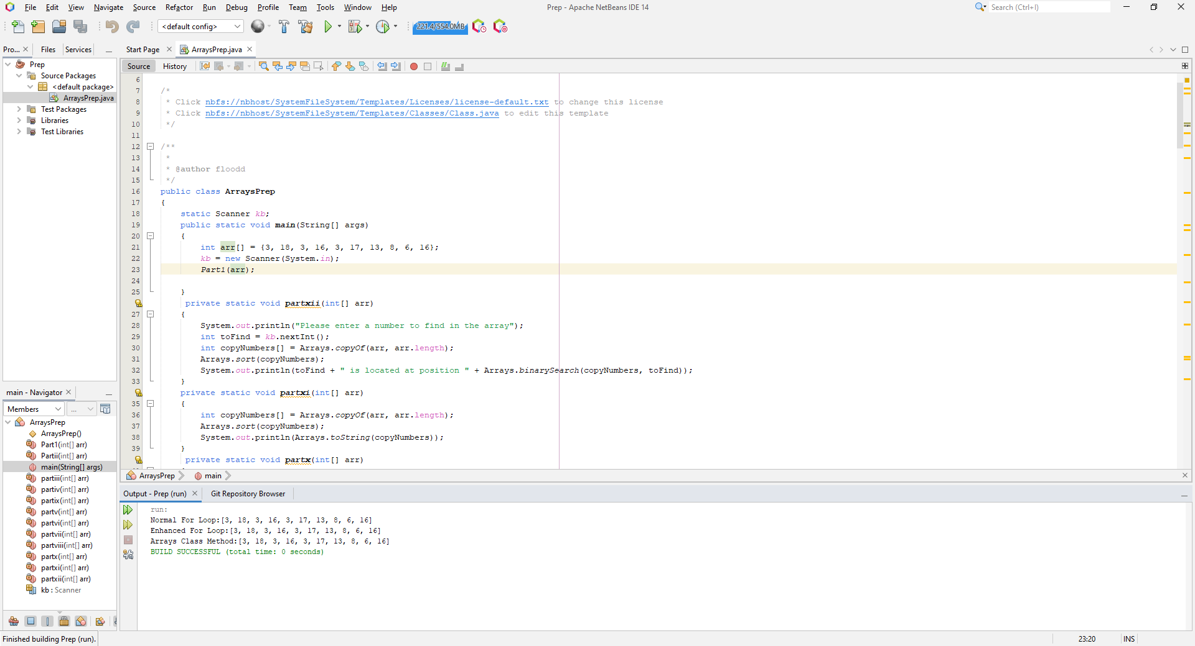

**Part ii**

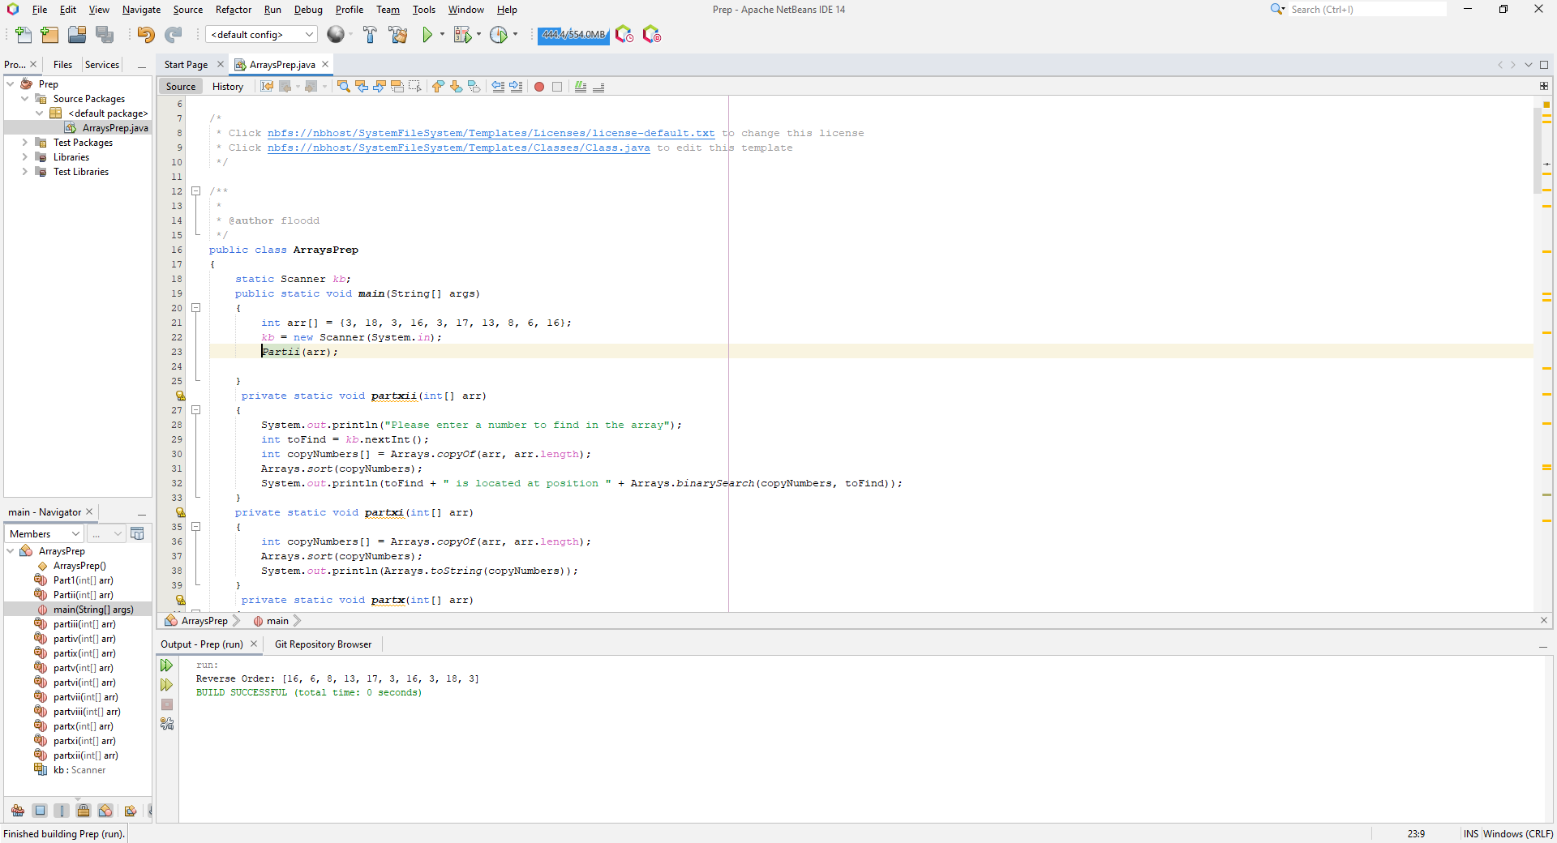

**Part iii**

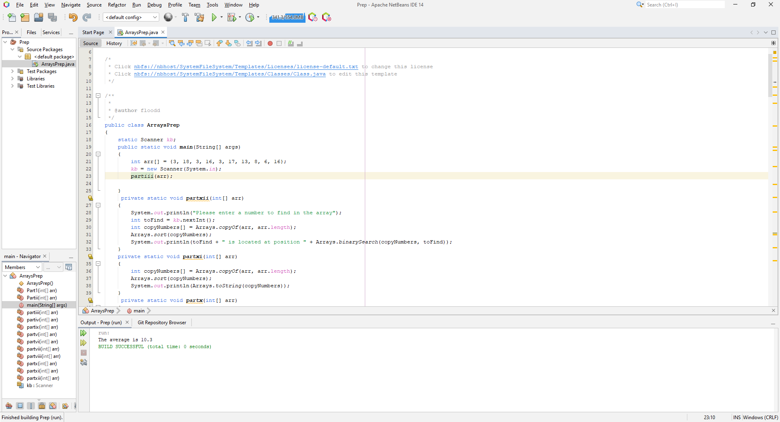

**Part iv**

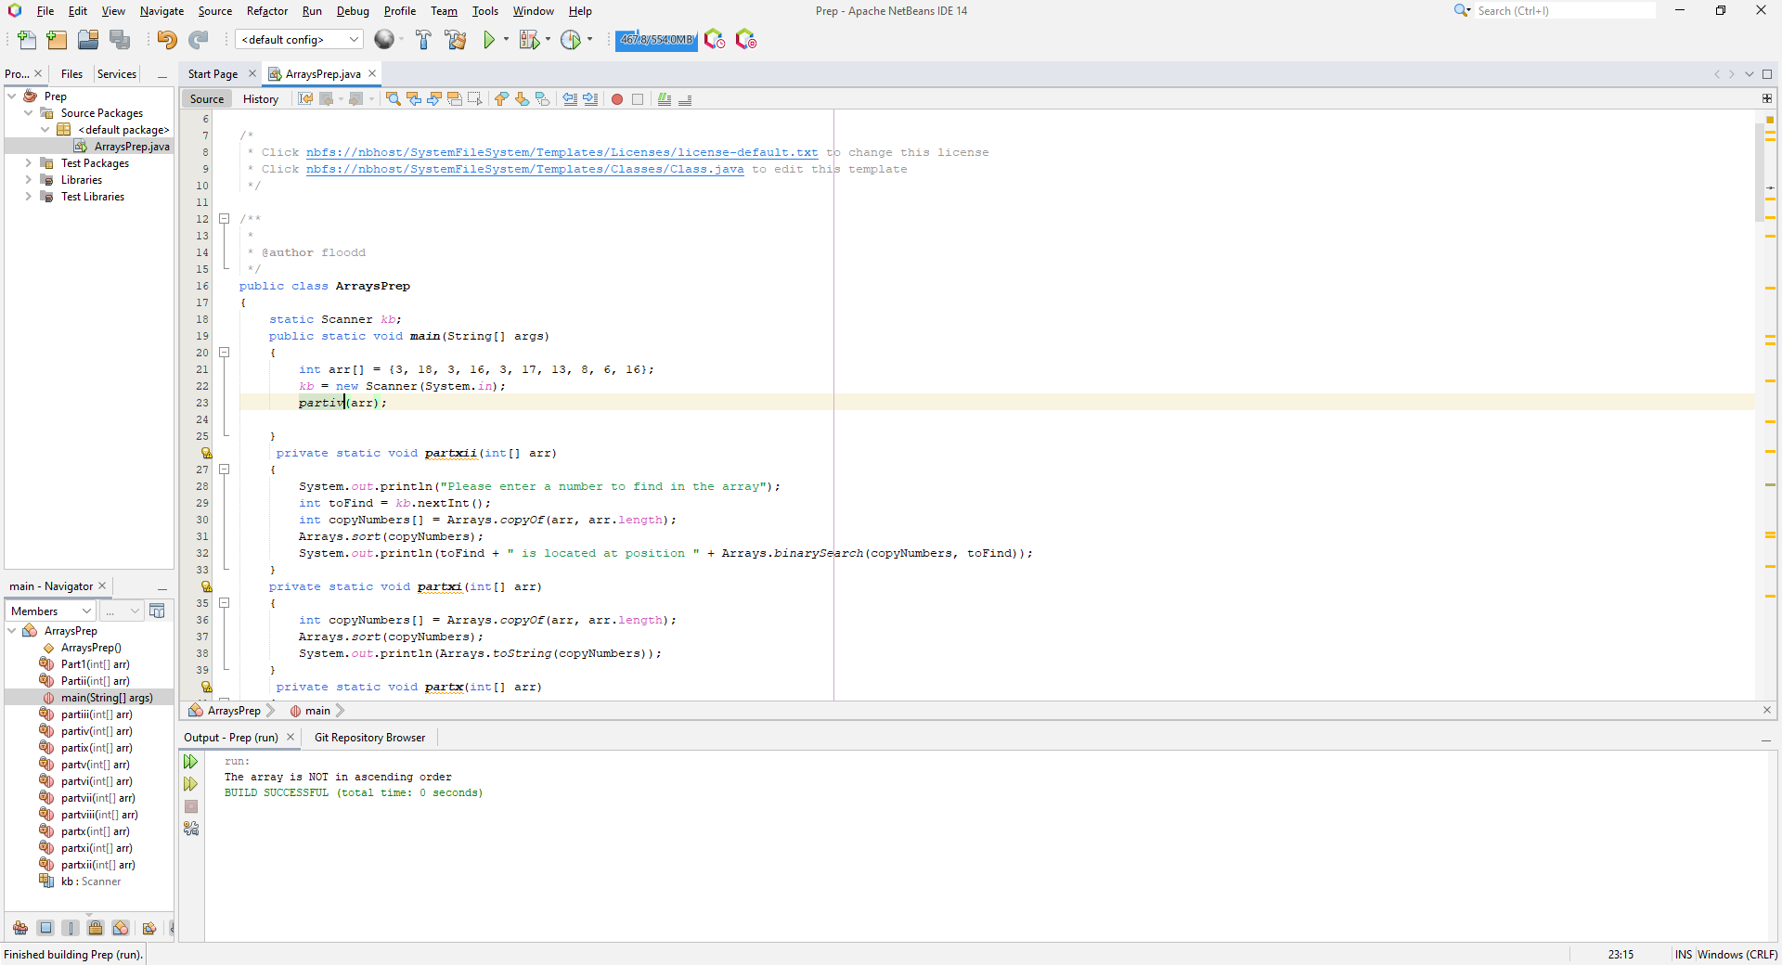

**Part v**

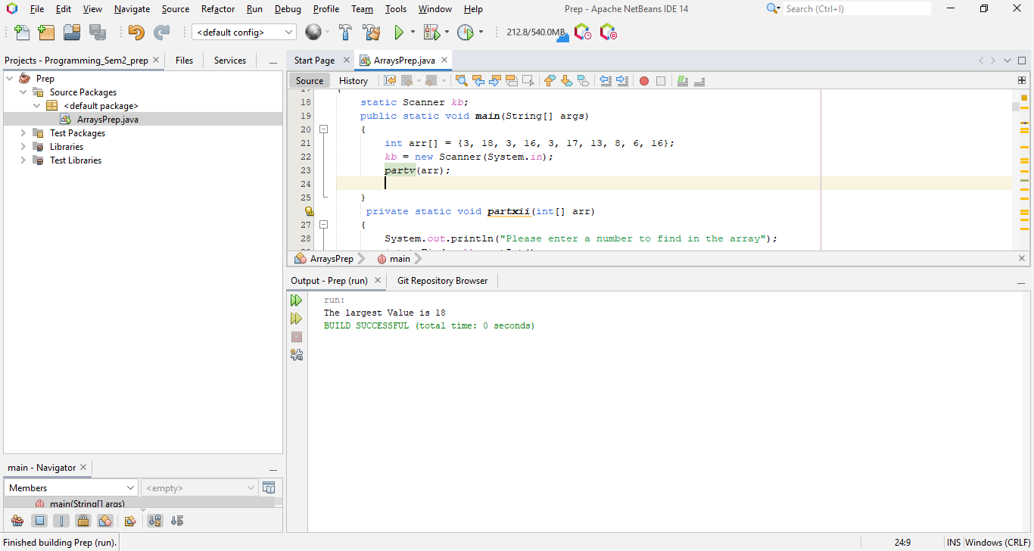

**Part vi**

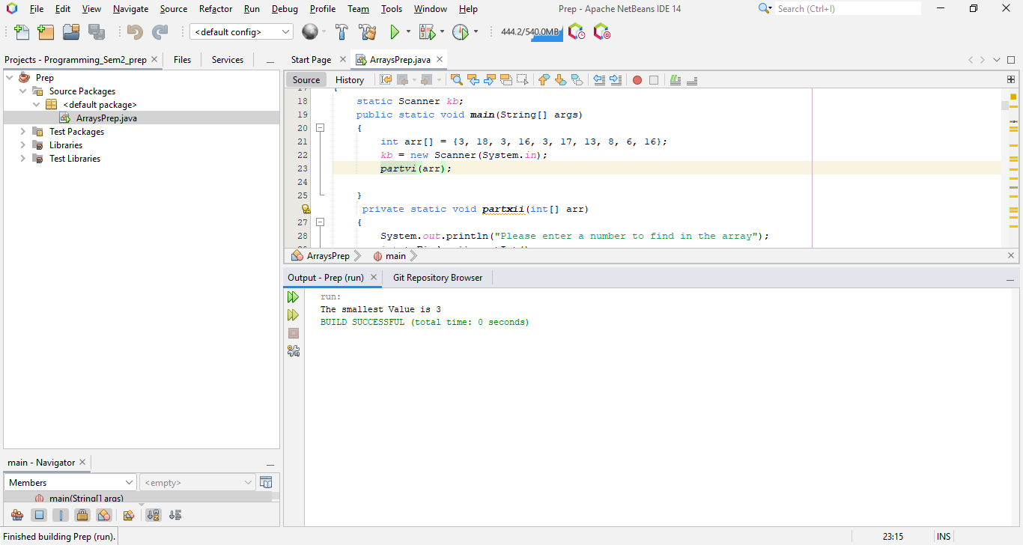

**Part vii**

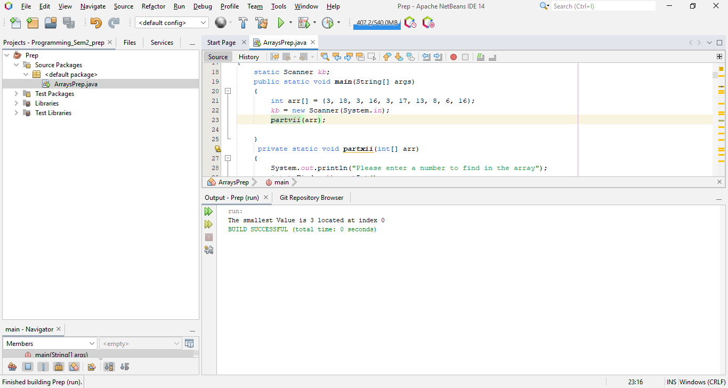

**Part viii**

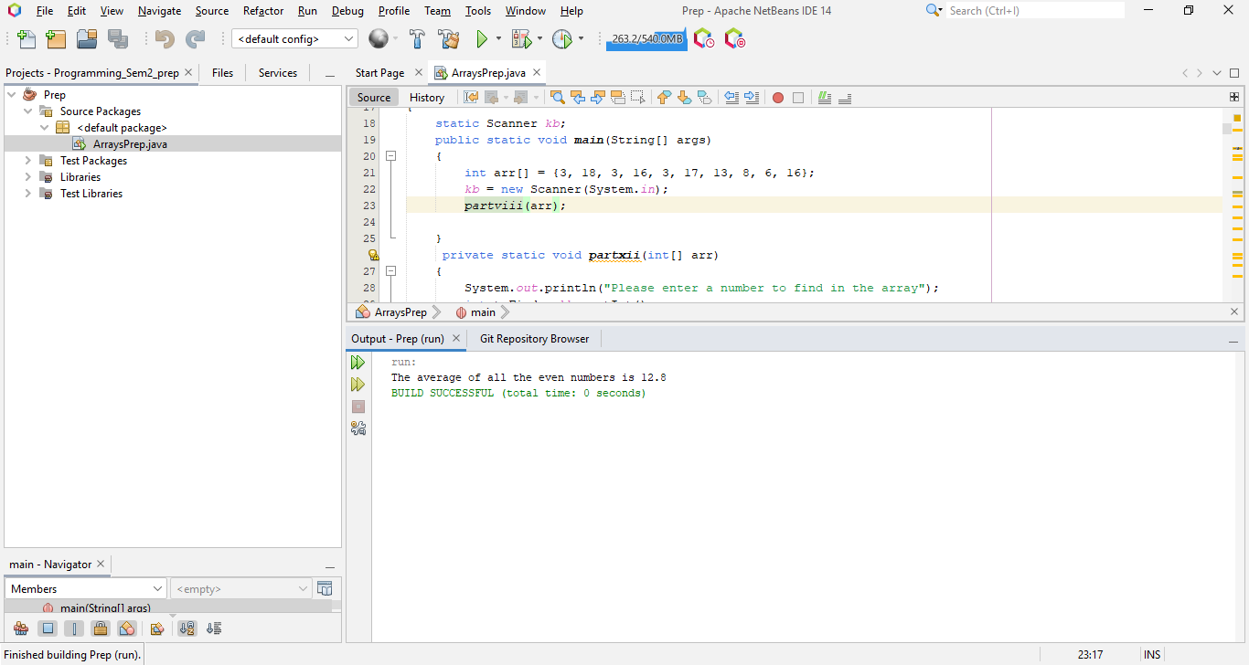

**Part ix**

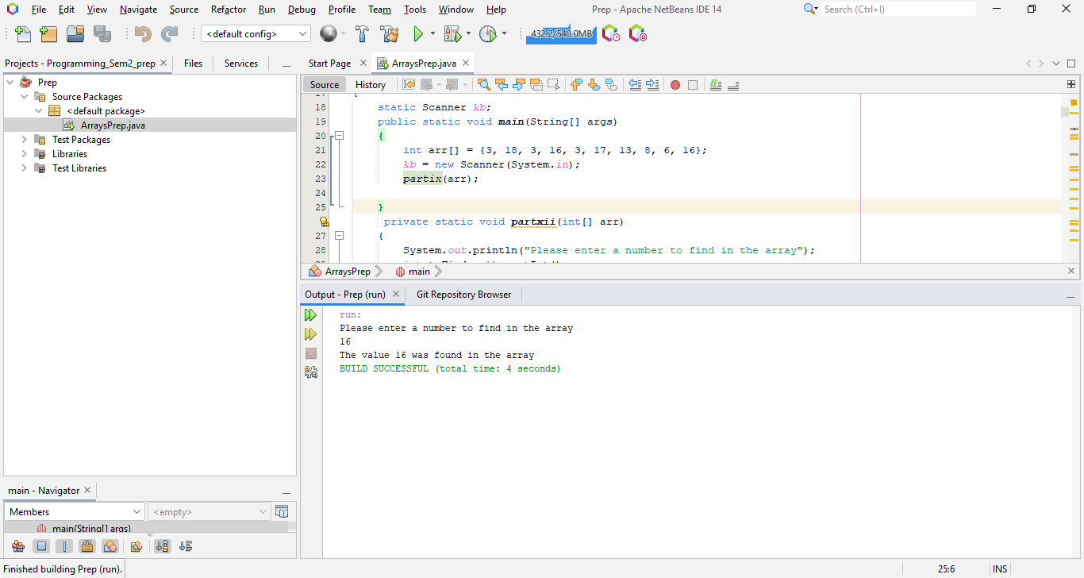

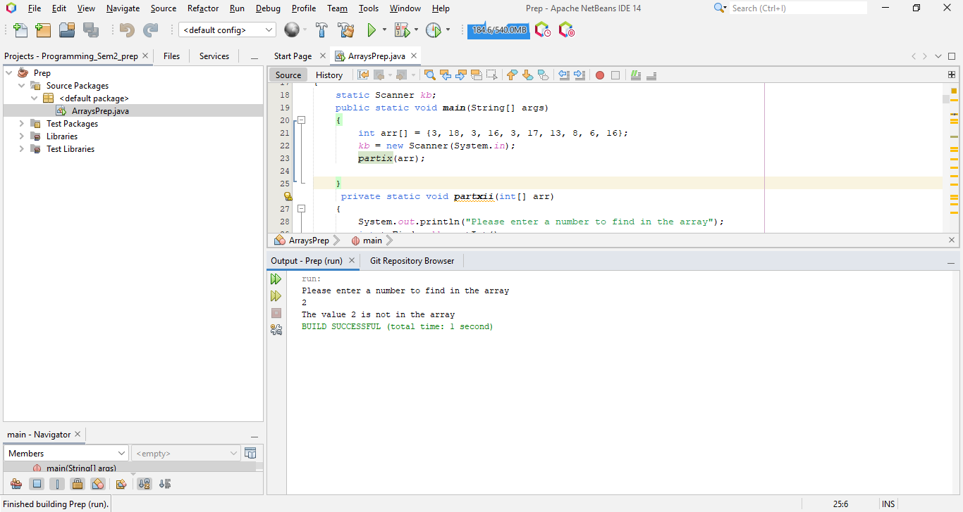

**Part x**

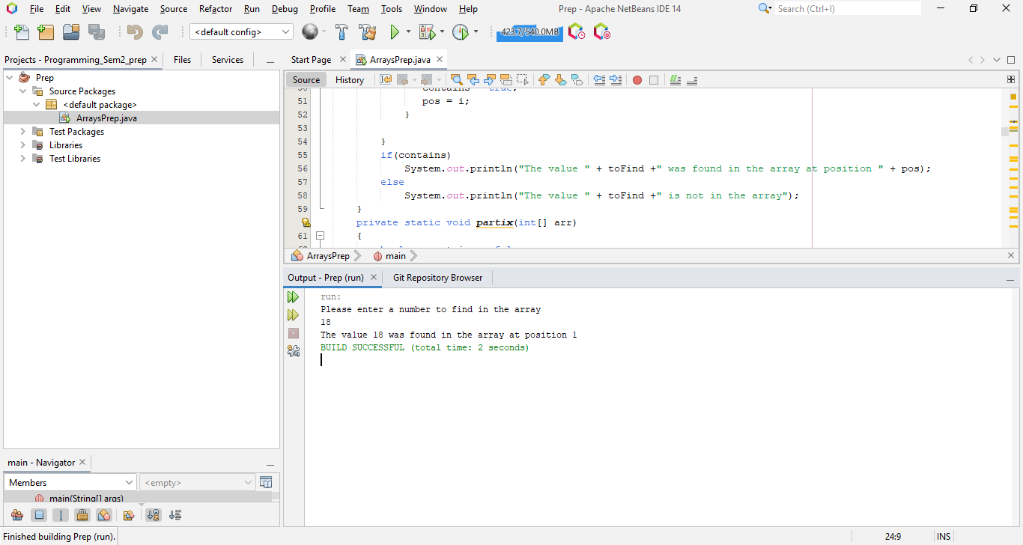

**Part xi**

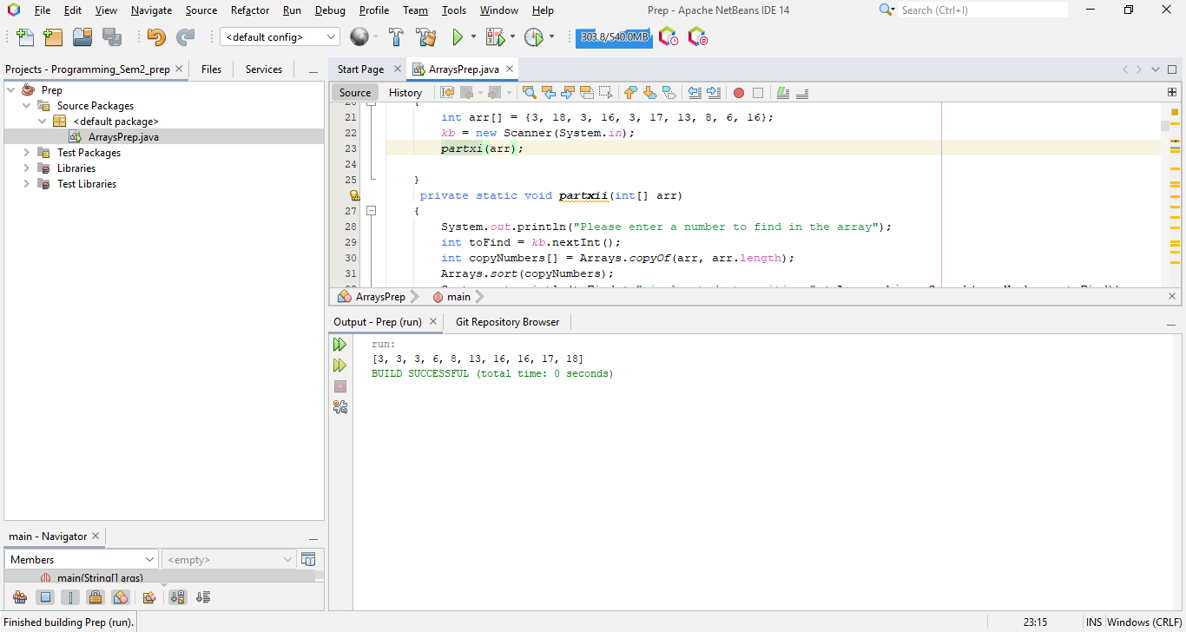

**Part xii**

